

[NCC Global Assignment]
Candidate Name: | Than Htut Aung
Candidate ID Number: | 200314
Center Name: | KBT001 - KBTC College (School of IT)
Unit: | Computing Project
Qualification: | L5DC
Date: | 4/4/2025
Total Word Counts: | 1378

Table of Contents
1.1 Project Background 2
1.2 The Aims and Objectives 3
1.3 Method of Solution / Architecture 3
1.4 Risk Assessment 4
1.5 Project Breakdown Structure and Gantt Chart 6
1.6 Project Deliverables (Artifacts) 7

Project Background

The current project is an online multiplayer `Guessing the word by drawing` game built to provide an interactive and fun gaming experience for users. Player will take turns to draw a given word on each round while remaining players will give the word by looking at the drawing canvas which the player drawn. These kinds of games have become popular but gaming experience is not perfect because of lacking good user experiences, high latency etc. So, we will try to improve these experiences, offering users a better performance and smooth gaming experience, will provide a fun and cozy version of the game.

Problem Statement
The existing games have performance issues related to real-time experience, high load server resulting latency and unable to find a match and so on. Some common issues include

- High latency in drawing and guessing interactions because of bad implementation of WebSocket and server optimization.
- Lack of optimized room management, resulting to bad matchmaking.
- Security vulnerabilities, such as cheating through browser console hacks or automated scripts.
- Bad UI/UX, which makes it difficult for players to play smoothly.
This project fix these problems by providing a scalable, low-latency backend and user-friendly UI and UX which will ensure the users to achieve an enjoyable and smooth gaming experience.

Scope of the Project
The scope of the project includes:
- Developing a frontend application with ReactJS.
- Building a backend server using NestJS for low-latency server.
- Implementing WebSocket-based to provide real-time experience for drawing and guessing words.
- Developing a room system where players can create and join with random generated codes (maximum of 8 players per room).
- Creating a scoring system based on the time taken to guess the word correctly.
- Integrate authentication for providing security and preventing cheats.

We will deploy our project in a cloud provider (eg AWS) using Docker containers. This project will provider users to have a smooth performance on gaming experience, low latency and high security.

The Aims and Objectives

Overall Aim
The main objective for our project is to create an online multiplayer, real-time scribble game with great user experience, low latency and high security server. The logic of the game is the game will let the users to join rooms, choosing drawer on each round while others will guess the word by looking at the scribble. And finally, we choose the winner who can guess the correct word.

Specific Objectives
To achieve this aim, the project will focus on the following objectives:

- Use ReactJS to create a responsive and interactive frontend application.
- Build backend sever using NestJS to provide game rooms and scoring system.
- Integrate WebSocket communication to provide real-time, smooth and low-latency experience among players.
- Build a room system where players can create, join, or leave game rooms. Maximum 8 players can join the rooms. Players will use random generated codes to join rooms.
- Implement a fair scoring system that awards points based on the speed of correct guesses to make a competitive gameplay.
- Consider security measures by preventing hacking attempts such as automated guessing or browser console manipulation.
- Ensure a user-friendly and good UI/UX, making the game funny and enjoyable for all users.

The project will be a fun and cool online Scribble game which will be recognized for its responsiveness, security, and user experience.

Method of Solution / Architecture

System Architecture
The application will be designed with a client-server architecture, where:

- The frontend React application will handle user interactions, game UI, and WebSocket connections.
- The NestJS backend will manage game logic, scoring, room management, API requests and provide WebSocket connections.
- WebSockets (Socket.io) will ensure real-time communication between players.
- A database (PostgreSQL) will store user accounts, scores, and room information.

Game Flow & Room Management

- A player creates a game room and shares the invite link with random code.
- Other players join the room (max 8 players per room).
- When the game starts, a random player is assigned as the drawer.
- The drawer choose a word or will randomly assigned a random word if he fail to choose in a given duration and starts drawing to match that word.
- Other players attempt to guess the word within a time limit.
- Players who guess correctly receive points based on their submitted time.
- The round ends, and the next player takes a turn.
- The game continues for a predefined number of rounds, and after that, the winner is announced.

Security Considerations

- Implementing rate-limiting and input validation to prevent spam and abuse.
- Using JWT authentication to secure user sessions.
- Preventing client-side exploits by securing WebSocket connections and implementing validation of chat box.
A secure and enjoyable user experience, minimal latency, and reliable real-time communication are all provided by this well-designed architecture.

Risk Assessment

To achieve a great scribble game, we need to identify the potential risks. Below is a structured risk assessment which we need to identify.

Risk | Likelihood | Impact | Mitigation Strategy
WebSocket Latency Issues | High | High | Optimize WebSocket implementation, use a CDN and efficient server regions
Server Overload | Medium | High | Implement load balancing and autoscaling for backend services
Security Vulnerabilities (Cheating) | High | High | Secure WebSocket connections, validate game state on the server, and implement anti-cheat mechanisms
Poor User Engagement Due to UI/UX | Medium | Medium | Conduct user testing, gather feedback, and improve UI/UX accordingly
Database Performance Issues | Low | Medium | Use indexing, caching (Redis), and optimize queries
Deployment/Hosting Features | Low | High | Use a reliable cloud provider with automated backups

By addressing these risks proactively, the project will ensure a secure, smooth, and high-performance gaming experience for users.

Project Breakdown Structure and Gantt Chart
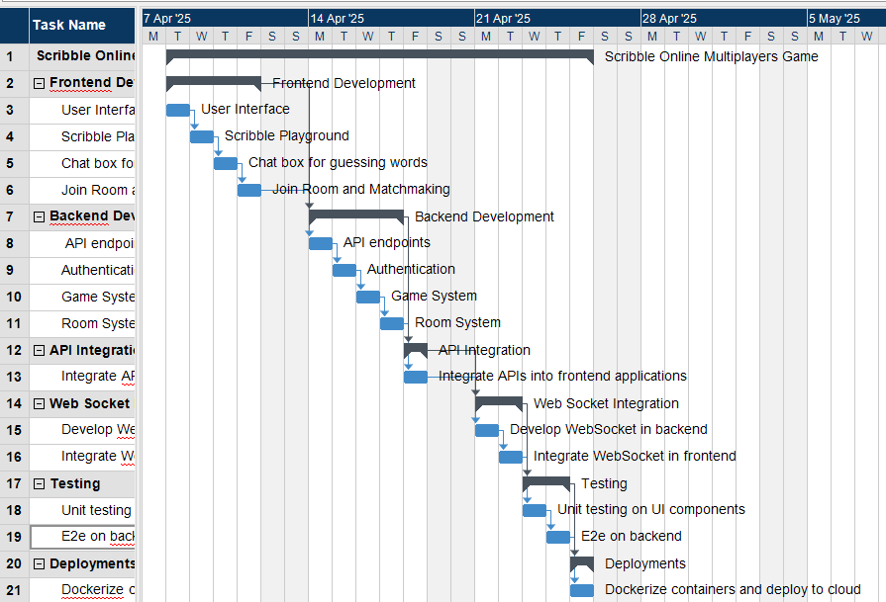
Fig 1. Gantt Chart for the project timeline

Timeline for the project

Frontend Development
- User Interface: Develop a smooth and responsive UI using modern frontend frameworks like ReactJS.
- Scribble Playground: Build the drawing canvas where players can draw the given word which other players will guess.
- Chat box for guessing words: Implement real time chat box for players to guess the given word during gameplay.
- Join Room and Matchmaking: Build a room-based matchmaking system where users can join or create games.

Backend Development
- API Endpoints: Build RESTful APIs to manage game logic, user sessions, and data handling.
- Authentication: Use JWT (JSON Web Tokens) for secure and stateless user authentication.
- Game System: Manage game flow, scoring logic, and round transitions on the server.
- Room System: Handle creation, joining, and real-time status updates of game rooms.

API Integration
- Integrate APIs into frontend applications: Connect frontend components to backend APIs.

WebSocket Integration
- Develop WebSocket in backend: Implement real-time communication for drawing and chat updates using WebSocket protocol.
- Integrate WebSocket in frontend: Implement real-time drawing and chat messages by integrating WebSocket clients.

Testing
- Unit testing on UI components: To make sure the UI components to be displayed as expected by using tools like React Testing Library.
- End-to-end (E2E) on backend: Integrate full flow testing using tools like Jest or Cypress to ensure the server perform perfectly.

Deployments
- Dockerize containers and deploy to cloud: Docker applications into containers and deploy to cloud services (e.g., AWS) for scalability.

Project Deliverables (Artifacts)

The project will produce the following key deliverables:

Frontend Application (React.js) – A smooth and responsive user interface for the game.

Backend Server (NestJS) – A scalable and secure server which handle game logic, WebSockets, and game rooms.

Database Schema and API Documentation – Detailed documentation of API endpoints and database structure.

WebSocket Communication Protocol – A protocol for providing real-time player interactions.

Deployment Configuration – Docker setup and cloud deployment instructions.

Testing Reports – Functional, performance, and security test results.

Final Report & User Guide – An extensive guide that explains how the system works and how to use it.

